
SHIRE HIGHLANDS EDUCATION DIVISION
2025 MALAWI SCHOOL CERTIFICATE OF EDUCATION MOCK
EXAMINATION

MATHEMATICS
Subject Number: M131/I
Thursday, 27th March, Time Allowed: 2 hours
8:00 - 10:00 am

PAPER I
(120 Marks)

INSTRUCTIONS
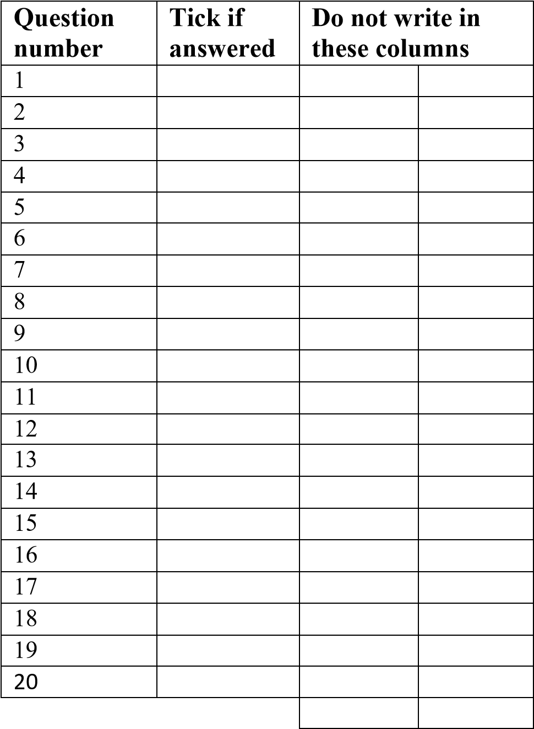
- This paper contains 10 printed pages. Please check.
- Answer all the 20 questions in this paper.
- The maximum number of marks for each answer is indicated against each question.
- Scientific calculators may be used.
- All working must be clearly shown
- Write your Examination Number at the top of each page of your question paper in the spaces provided.
- In the table provided on this page, tick against the question number you have answered.
- At the end of the examination, hand in your paper to the invigilator.

- Factorise completely 4p²+16pq-84q² ( 4 marks)

- Express $\frac{\sqrt{y}-√3}{\sqrt{y}+√3}$ with a rational denominator ( 4 marks)

- Make r subject of the formula, $a-\sqrt[3]{\frac{r}{m+1}}=\frac{1}{p}$ ( 4 marks)

- Given that $\underline{r}=\left({-4 \atop 7}\right)$,find the image of point (8,-6) under translation 4$\underline{r}$. (4 marks)

- Matrix M=$\left(\begin{matrix}4 & 4 \\ -2 & -2\end{matrix}\right)$ is such that $M² =kM$, where k is a constant. Calculate the value of k. (5 marks)

- Given that $x+2$ is a factor of $x^{3}+{4x}^{2}+7x+b$ ,find the value of b. (5 marks)

- Calculate the distance between points (1,4) and (4,0). (5 marks)

- Calculate the coordinate of the turning point on the curve $y=x^{2}-6.$ (5 marks)

- Given that $\log_{5}{\frac{1}{25 }}=4x-10$ ,find value of x. (6 marks)

- Figure 1 shows a cone of base diameter 14cm.
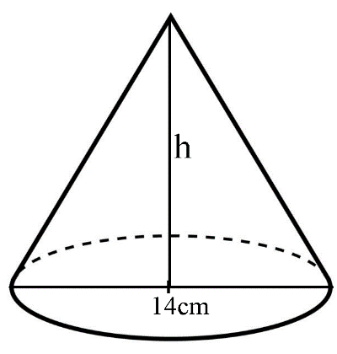
Figure 1
If the volume of the cone is 462 cm³,find height of the cone. ( 4 marks)

- Figure 2 shows speed-time graph of a moving object.
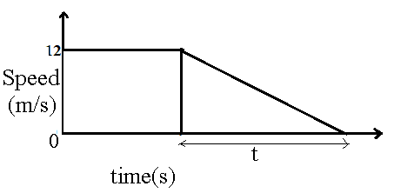
Figure 2
Given that the deceleration of the object is 0.4 ms⁻², calculate value of t. (4 marks)

- The angles of elevation of the top of a tower from Mike and Benzo are 32⁰ and 27⁰ respectively. If Mike and Benzo are on the opposite sides of the tower and the tower is 98m high, calculate the distance between them, giving the answer correct to the nearest whole number. (6 marks)

- The 4th term of a geometrical progression is 54 and the common ratio is 3.Calculate the 9th term of the geometrical progression. (5 marks)

- The distance of the chord from the centre of the circle is 4 cm. If the diameter of the circle is 10 cm, calculate the length of the chord.
(5 marks)

- Figure 3 shows a cyclic quadrilateral ABCD.EC and ED are tangents to the circle ABCD at C and D respectively. BCF and DAG are straight lines such that angle $CDE=41°$ and angle $ECF =62°.$
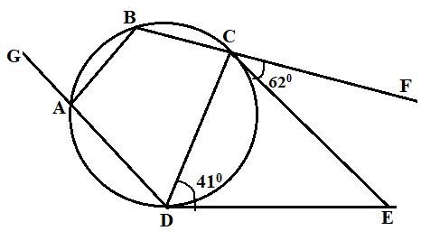
Figure 3
Calculate the value of angle GAB. (5 marks)

- Given that the function $f\left(x\right)=x^{4}+x^{0} +3$,calculate f(2^{¼}). (4 marks)

- A quantity x varies directly with the square root of y and inversely as z. Given that $x=4$,when $y=3$ and $z=1$,find y when $x=6$ and$z=2.$ (6 marks)

- The ratio of areas of two circles is $16:49$.Given that the radius of the bigger circle is 21cm,find the radius of the smaller circle. ( 5 marks)

- Solve the equation $x^{2}-3x-7=0,$ giving the answer correct to 2 significant figures. ( 6 marks)

- On the graph paper provided, sketch the region described by the following inequalities by shading the unwanted region: $x≥0, y≤4, 2x+y≥3$ and $x-y<5$. (6 marks)

